SSERVICENOW PROJECT SUBMISSON

Requesting WiFi Access Through ServiceNow

Submitted by

B.Venkata Tejesh au723921243007

G.Samba Siva Reddy au723931243019

V.Vennela au723921243054

CM.Praveen Kumar au723921104012

**Arjun College of Technology , Coimbatore Anna University**

**Chennai -600 025**

**Requesting WiFi Access Through ServiceNow Project Overview :**

Thomas is a new employee at XYZ Corporation. As part of his onboarding, he needs access to the company's WiFi network to perform his job duties. XYZ Corporation uses ServiceNow to manage all access requests, including WiFi passwords. ServiceNow is also available on mobile devices, allowing Thomas to raise a request conveniently from his smartphone.

**Objectives :**

* To provide a centralized platform for users to request WiFi access.
* To automate the approval and provisioning process for WiFi access requests.
* To ensure compliance with network security policies during the request and approval process.
* To enhance the user experience by providing a simple, self-service interface for WiFi requests

**Key Features and Concepts Used :**

* Service Catalog,
* Catalog items,
* Variables,
* Portal,
* Service Portals,  Workflows,
* Email Notification.

**Detailed Steps To Solution Design :**

**Implementation :**

1. Open service now.
2. Log in to your ServiceNow instance using the provided credentials. Now you will navigate to the ServiceNow.

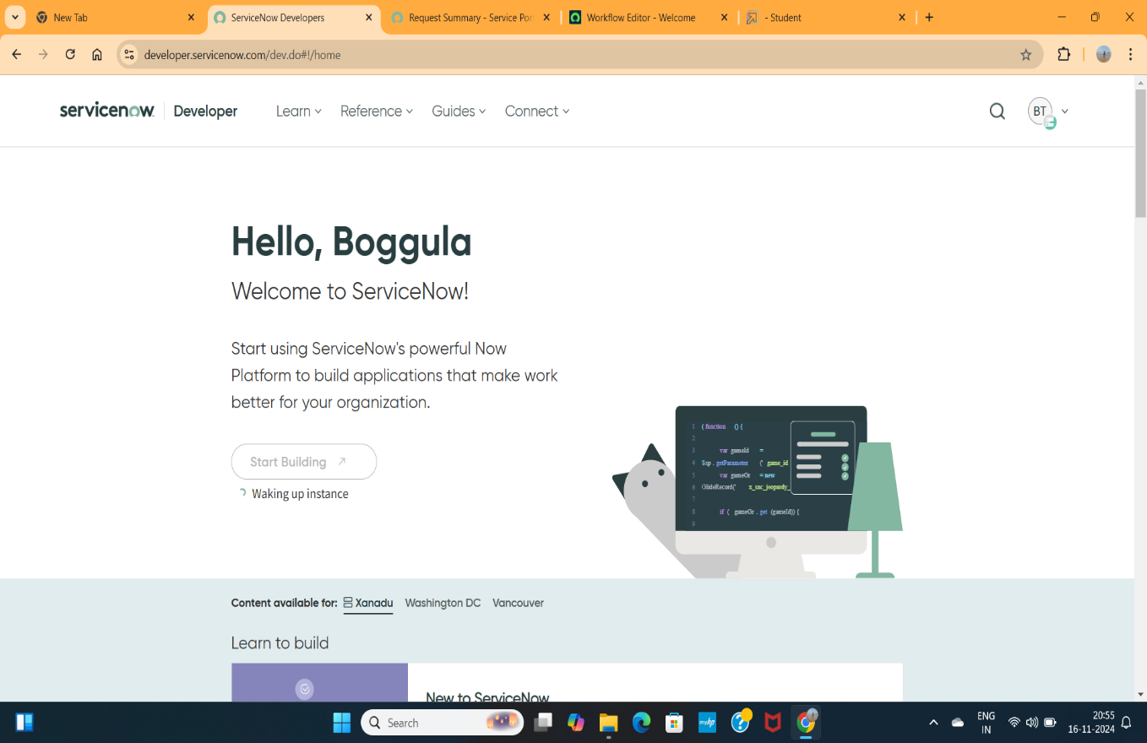

1. Click on All >> Open “Service Catalog” >> maintain items.

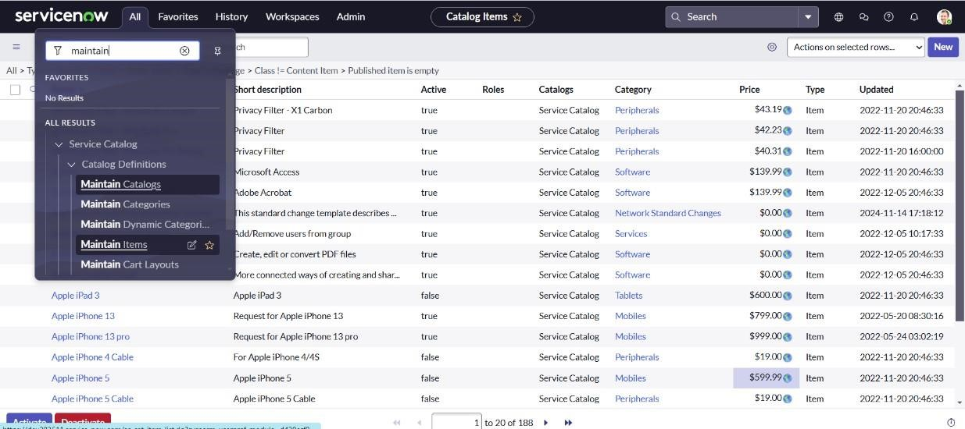

1. To add a new Service Catalog item in ServiceNow, follow these steps to enter a title for the item, select the category ,select the catalog , and upload the images. Here’s a step-by-step guide:

* 1. Give a Name for the Catalog Item
  2. Select the Catalog
  3. Select the Category
  4. Save the Item

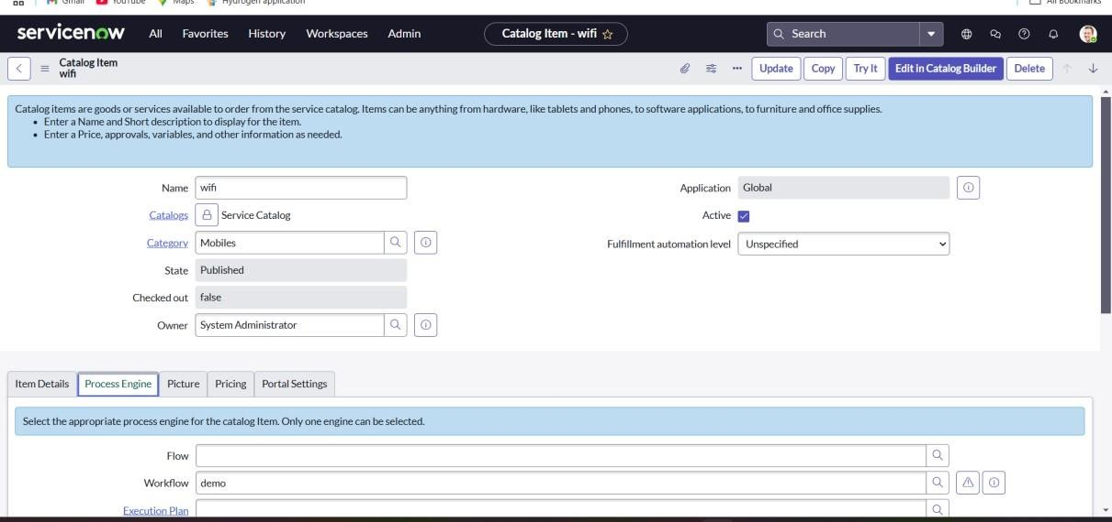

The created items which are under service catalog are uploaded directly in service portal.

1. Create a Workflow as per your requirements. Workflow>> “Workflow

Editor”.

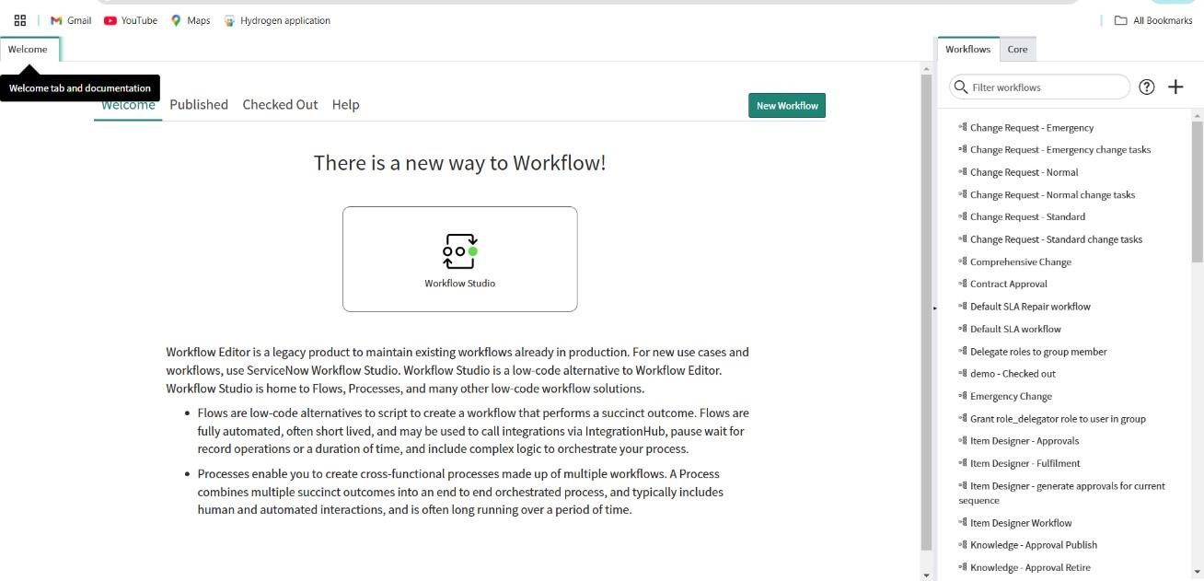

1. Click on create “New”.

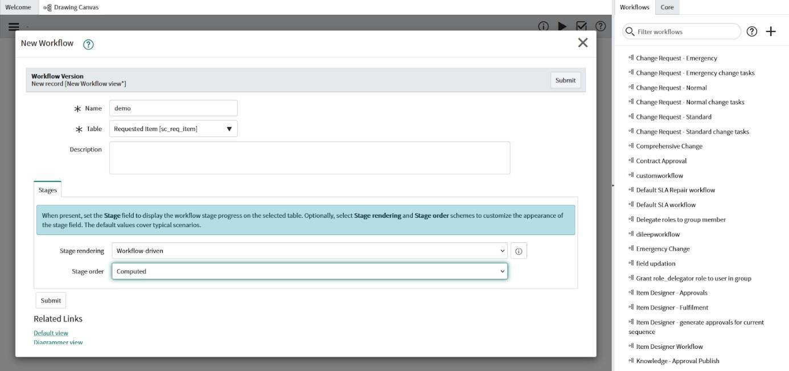

1. Enter the name of the workflow.
2. Select table name as “sc_req_item”.
3. Click on “Submit”.

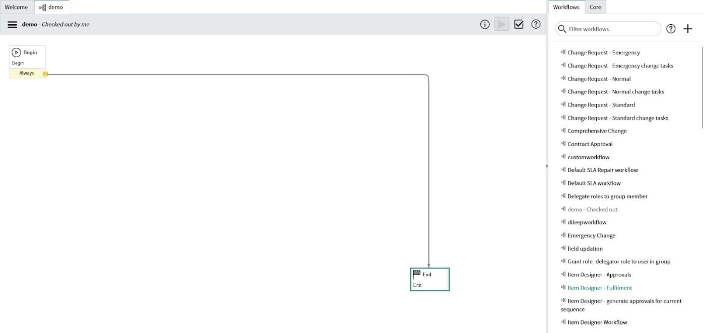

1. This the outlook of workflow.
2. So we should add needed condition.

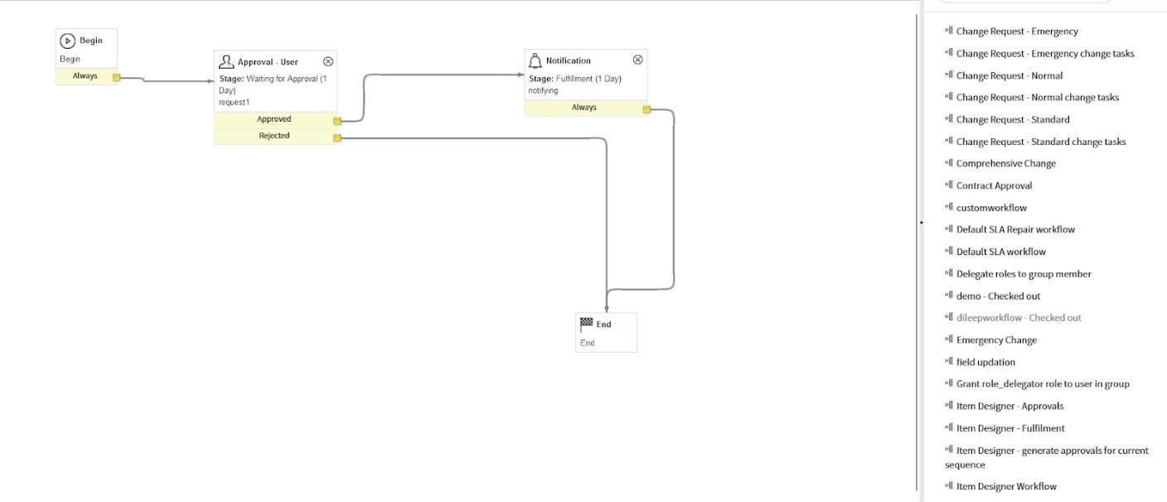

1. This is the workflow after adding needed conditions.

When the reauest is generated ,the Approval request automatically generated,After

1. approving the approval the user will get notification about their order.

6. Add created Workflow to Catalog item.

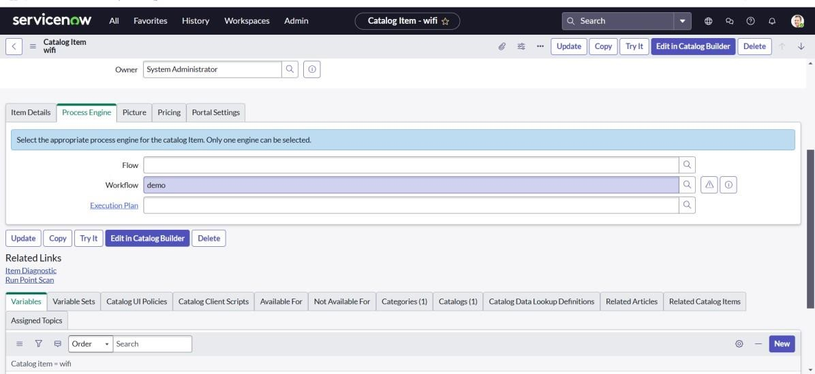

1. Go to “maintain items”,Open “wifi” item ,then open it’s “Process Engine”.
2. Select the Workflow to be performed, that is “demo”.

7. Open Service Portal, and request for your created item

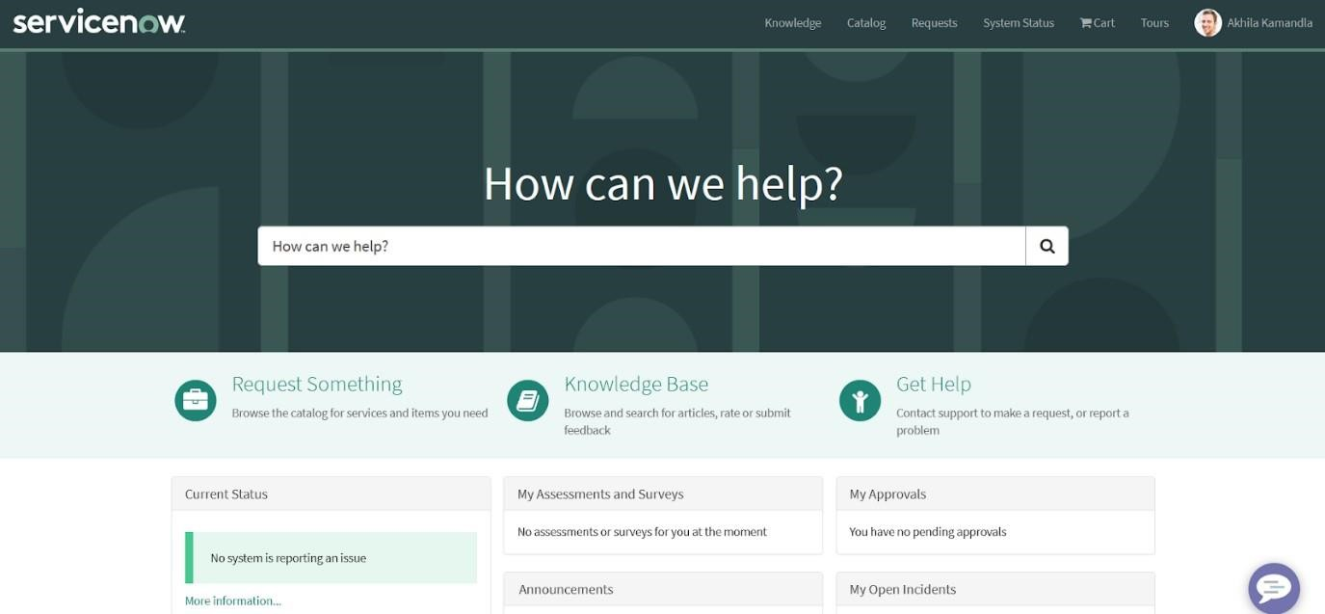

1. Go and search for item “wifi”

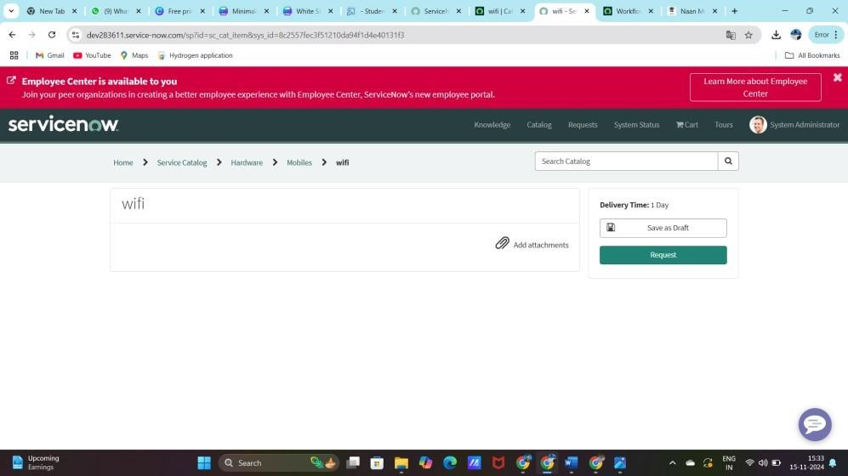

2.Click on “Request”.

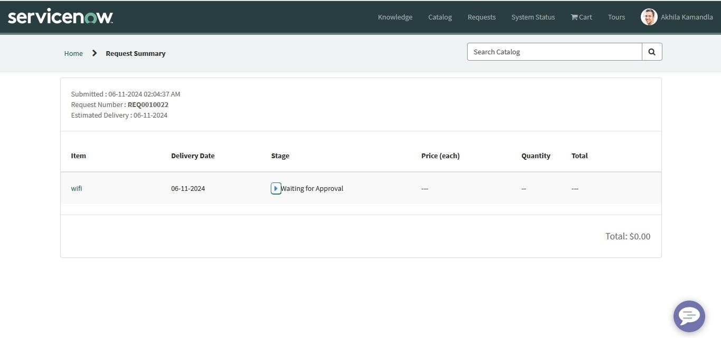

# Result

**1. Testing Wi-Fi Access Request:**

Once the request item and workflow are created, it's important to test the process to ensure that it's functioning correctly.

**Steps for Testing:**

1. **Submit a Test Request:**
   * Submit a request for Wi-Fi access as an end user.
   * Check if all fields are being captured correctly, and ensure the approval workflow is triggered.
2. **Check Approval Process:**
   * Ensure that the request is routed to the correct approver.
   * Verify that the approval or rejection notifications are sent out correctly.
3. **Verify Access Provisioning:**
   * If Wi-Fi access is provisioned automatically, ensure the relevant team (e.g., network team) is notified, and verify that the user is granted Wi-Fi access.
   * If the process is manual, confirm that the network admin can grant access based on the approved request.
4. **End-User Experience:**
   * Check the end-user experience by confirming the approval and whether they can access Wi-Fi after the request is fulfilled.
   * Ensure that they receive relevant notifications (e.g., when access is granted or denied).

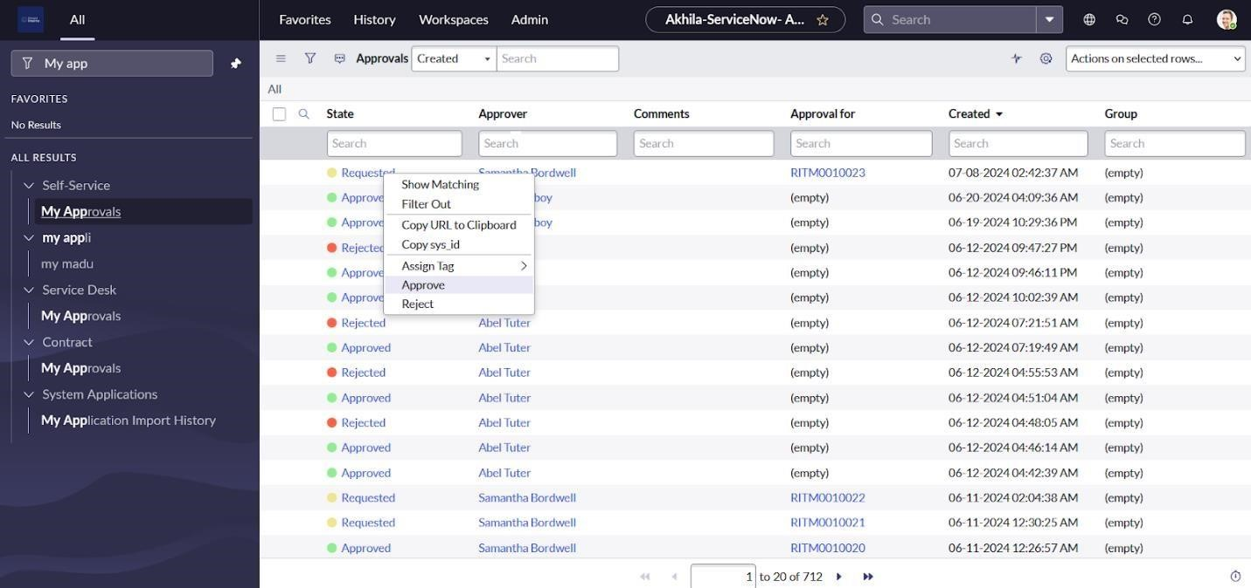

1.Open “My Approvals” 2.Right Click on “Requested”, and click on Approve.

3. **Now go to emails, You will get a password in email.**

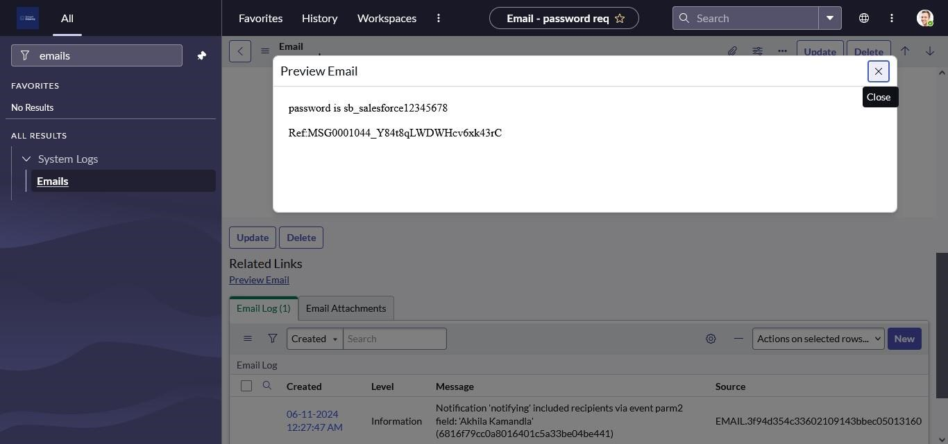

# Conclusion

In conclusion, deploying a Wi-Fi access request process through ServiceNow streamlines access management while ensuring security and compliance. By creating a catalog item, automating workflows, and setting up approval processes, you can simplify user requests and improve efficiency. Thorough testing and validation ensure the process works as intended, with proper access control and data integrity. Once deployed, the system can be monitored to ensure smooth operation and optimal performance. Ultimately, this solution enhances user experience while maintaining robust network security.